**Technical Proposal for Medical Imaging Solution**



Elevating HealthCare with AI Assisted Imaging

Prepared For: **Customer Name**

Date: Please Enter Today’s Date

Prepared By: Mohamed Bahaa

© copyright by PaxeraHealth corp. 2021 1

**Table of Contents**

Confidentiality Commitment and Contact Information 4

Statement of Confidentiality & Non Disclosures 4

Contact Information 4

Executive Summary 5

Overview of PaxeraHealth PACS Solution 6

Key Features and Benefits: 6

Certifications and Compliance: 7

Software Specification 8

**PaxeraArchive:** Image Archive & Management Software 9

DICOM 9

**PaxeraUltima 9th Gen.** 10

PaxeraUltima 9th Gen at a Glance 15

PaxeraUltima Benefits: 15

PaxeraUltima Instant Chat & Secure Messaging: 16

Image Manipulation and Visualization: 16

Tools 17

Archiving and Study Transfer 17

**AI for diagnostic assistance** 18

Mammography module 18

CT module 18

Pulmonary radiography 19

AI to improve workflow: 19

**PaxeraRep: Medical Reporting Module** 20

Reporting Tools: 21

**Cardio Structural Reports** 23

**Mammography Structural Reports** 23

**Zero-Footprint Module (PaxeraZFP):** 24

**PaxeraRIS** 27

PaxeraRIS at a Glance 27

PaxeraRIS Benefits: 28

Full automation for maximizing resources utilization 29

Comprehensive Scheduling & Registration 29

Comprehensive Worklist 30

Dashboard for Business Intelligence 31

**PaxeraBroker HL7 & Worklist Generator** 33

PaxeraBroker Key Features 33

**Critical Results** 34

**Peer Review Module** 35

**Emergency Department Discrepancies Module** 36

**Sharing & Collaboration:** 37

**Streamline Workflow:** 37

**Advanced Dashboard and Business Analytics Dashboard:** 37

**Patient Portal Module** 39

**Referring Physician Portal** 40

**Tele-Radiology** 41

Scope of Work 42

Installation of PaxeraHealth’s System 42

Testing PaxeraHealth’s System 42

Go-Live 43

Training 43

Project Milestones 44

Solution Technical Specifications 46

**Proposed Solution:** 47

Back End System Design: 47

Front End System Design: 47

# Confidentiality Commitment and Contact Information

## Statement of Confidentiality & Non Disclosures

This document, prepared by PaxeraHealth, contains proprietary and confidential information. The content is provided exclusively for the consideration of **Customer Name** may not be used shared, or disclosed to any third party without the express consent of PaxeraHealth. All recipients of this document, by their receipt and review, acknowledge and agree to maintain the information in strict confidence and to use it only for the purpose of evaluating a potential business relationship with PaxeraHealth.

## Contact Information

For further inquiries or to discuss the contents of this proposal, please reach out to us:

**Headquarters - USA Corporate Office**

* **Address:** 85 Wells Ave, Suite 120, Newton, MA. 02459
* **Phone:** 1-888-430-0005 | 1-816-817-4648

**Zone 2 Office - Cairo, Egypt**

* **Address:** Smart Village, Building B115, Cairo, Egypt
* **Phone:** +20-23-537-2525 | +20-23-536-5713

**General Contact**

* **Email:** Presales@paxerahealth.com
* **Website:** [https://paxerahealth.com](https://paxerahealth.com/)

# Executive Summary

PaxeraHealth is dedicated to transforming the efficiency, accuracy, and patient experience in healthcare environments. Our technical proposal outlines a state-of-the-art PACS/RIS solution, meticulously designed to replace outdated imaging systems that currently serve as bottlenecks in critical healthcare workflows.

Our cutting-edge solution is engineered to optimize imaging workflows comprehensively, providing secure digital image management, advanced visualization tools, and seamless integration with existing healthcare systems. It utilizes the latest streaming technology, ensuring that DICOM images are accessible within seconds, thereby enhancing the capability and system availability. With robust support for the HL7 protocol, our solution promises full integration with HL7 compliant EHR/EMR/RIS vendors.

We are confident that the deployment of PaxeraHealth's PACS/RIS solution at **Customer Name** will yield significant improvements across various performance metrics. The anticipated outcomes include faster diagnostic and treatment turnaround times, elevated diagnostic confidence, and improved collaboration among care teams. Moreover, the hospital will benefit from a streamlined, paperless, and cost-effective imaging operation that is both scalable and future-proof, ensuring that as your facility grows, our solution will adapt and expand to meet evolving demands.

PaxeraHealth Corp is proud to present this business proposal and looks forward to the opportunity to discuss how our solutions can be tailored to meet the unique needs of **Customer Name**.

# Overview of PaxeraHealth PACS Solution

PaxeraHealth is at the forefront of revolutionizing medical imaging and data management through our advanced PACS solution, designed to meet the specific needs of **Customer Name**. Our solution stands out for its unparalleled performance, offering seamless archiving and efficient management of diverse study types. By integrating various medical imaging modalities, we ensure that your healthcare facility can streamline operations, enhance diagnostic processes, and ultimately improve patient care.

Our PACS solution is engineered to facilitate the seamless flow of DICOM data across your healthcare network. By enabling the main data center to receive all DICOM data from connected radiology centers, we eliminate data silos and foster a more integrated and collaborative environment. This cohesive data management strategy not only improves the speed and accuracy of diagnoses but also significantly enhances the efficiency of daily medical operations.

## Key Features and Benefits:

* **Optimum Performance**: Engineered for high reliability and uptime, ensuring that your healthcare delivery is uninterrupted and consistently efficient.
* **Seamless Archiving**: Offers robust archiving capabilities for multiple study types, making it easier to store, retrieve, and manage medical images and related data.
* **Future-Ready**: Designed with scalability in mind, our solution can adapt to the evolving needs of your healthcare facility, accommodating new technologies and modalities as they become available.
* **AI-Embedded PACS for Automatic Segmentation and Radiomics:** By integrating AI-driven segmentation and radiomics analysis into the PACS workflow, healthcare professionals gain access to detailed information about the anatomical structures present in the images, along with quantitative metrics that can aid in diagnosis, treatment planning, and patient management.
* **Comprehensive Integration**: Our PACS solution supports full integration with HL7 compliant EHR/EMR/RIS systems, enabling a unified approach to patient data management.
* **Enhanced Accessibility**: Facilitates quick and easy access to DICOM images and data across the facility, improving collaboration among healthcare professionals and speeding up the decision-making process.

At PaxeraHealth, we are committed to delivering a PACS solution that not only meets the current needs of **Customer Name** but also anticipates the demands of the future. Our goal is to empower your facility with the tools and technology needed to achieve a total paperless system, enhance operational efficiencies, and provide superior patient care.

## Certifications and Compliance:

Our solution proudly meets the highest standards of quality and regulatory compliance, being **CE** certified, **FDA** approved, **HIPAA** compliant, and **ISO** 13485:2016 certified. These certifications underscore our commitment to delivering safe, reliable, and compliant medical imaging solutions. For detailed documentation on our certifications.

# Software Specification

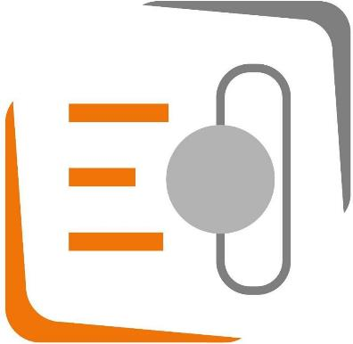

## **PaxeraArchive:** Image Archive & Management Software

Our solution is a modular enterprise imaging platform that can be incrementally licensed and adopted. Our flexible approach allows your organization to select a single scalable, multi- specialty enterprise-imaging vendor solution, while only investing in what you need, when you need it.

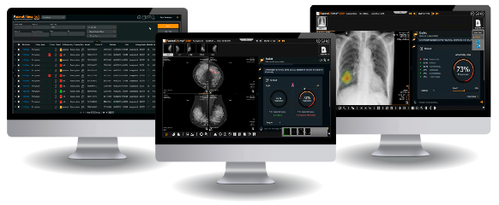

PaxeraArchive archives patient studies; including images, cine-loops, voice notes, reports, and patient information. The PaxeraArchive solution includes features to archive patients, retrieve studies, print studies, edit patient reports, and record voice notes.

PaxeraArchive solution consists of a group of software and hardware components that have been specifically chosen to provide the maximum performance and scalability.

* + - Supports all DICOM modalities.
    - Multi-Level relational database structure for patients/studies/series and images.
    - Supports pre-fetching and auto-routing of patients to the modalities.
    - Scalable and Upgradable
    - Multi-Lingual
    - Integrated with Cerner HIS at the highest level (FHIR)
    - Easy Administration
    - Full HIPAA Compliance
    - All DICOM Features

### DICOM

* Supports almost all DICOM storage classes e.g. US, CR, RF, XA, CT, MRI, NM, VL, SC, OT… etc.
* DICOM Send (Store SCU)
* DICOM Receive Server (Store SCP)
* DICOM Query & Retrieve (SCU)
* DICOM Print (SCU)
* DICOM modality worklist support
* DICOM Single Media Archive “Part-10”
* DICOM Storage Commitment Enhances the doctor’s work-list building by providing flexible search capability using different parameters

## **PaxeraUltima 9th Gen.**

PaxeraUltima is class data management system that consolidates medical images from multi- modality, multi-ology, full-fledged diagnostic web viewer, designed to host images stored on the local server or a cloud configuration. A gateway is used to connect the modalities (via DICOM connections) to the local server. The self-customizable workstation software can be used to efficiently interpret radiology, cardiology, Mammography, pathology, GI, and any type of non- DICOM image.



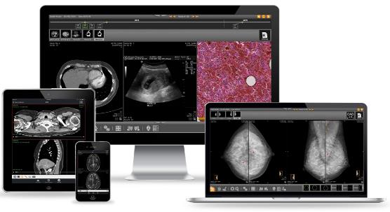

We use an ultra-fast unique streaming technology to view images and cine’s directly from the local server. The image viewer operates off secured https web interface, downloads start immediately after selecting the required patient, the image of interest will load first – and in the background the rest of the study will load – resembling an almost zero download time, even for very large studies.

PaxeraUltima solution has been designed to support your facilities optimization and growth, and our unmatched support enables you to focus on what matters, while we deal with the rest.

PaxeraUltima 9Th gen is now equipped with advanced AI algorithms capable of automatic segmentation of organs and vessels from CT scan medical imaging data. The AI-driven segmentation process accurately identifies and delineates anatomical structures, spine and rib labelling ensuring precise localization of organs and vessels within the images

The solution offers also a comprehensive radiomics analysis feature, which extracts a full list of radiomics data from the segmented structures. Radiomics refers to the quantitative analysis of medical images to extract a large number of features, such as shape, texture, and intensity, which can provide valuable insights into tissue characteristics, disease progression, and treatment response.

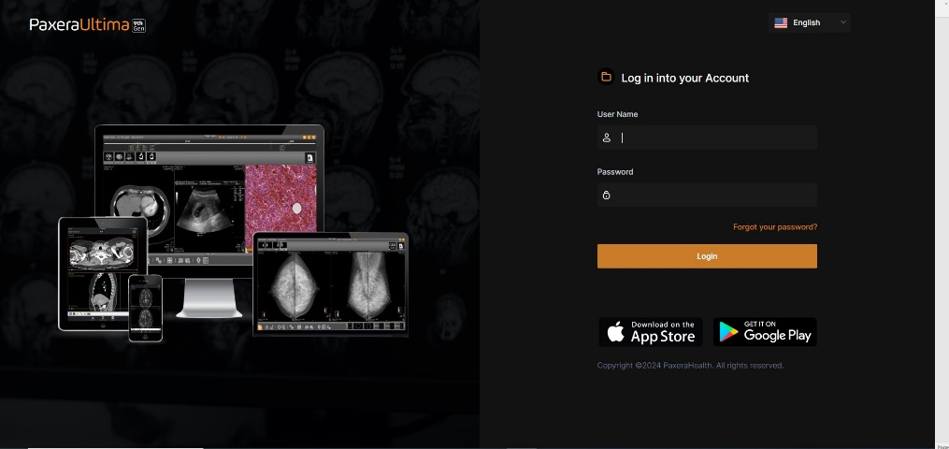

**Intuitive, user-friendly interface featuring a comfortable dark mode for extended use**

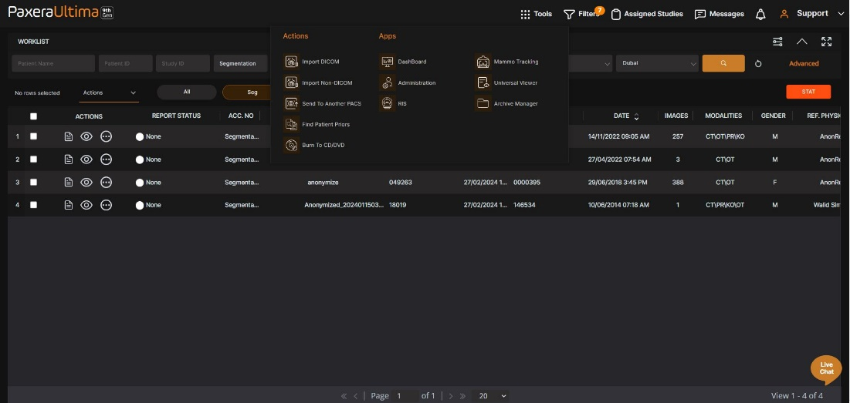

**Facilitates seamless study transfers to any PACS system, enhancing interoperability**

**Ability to add specific favorite filters**

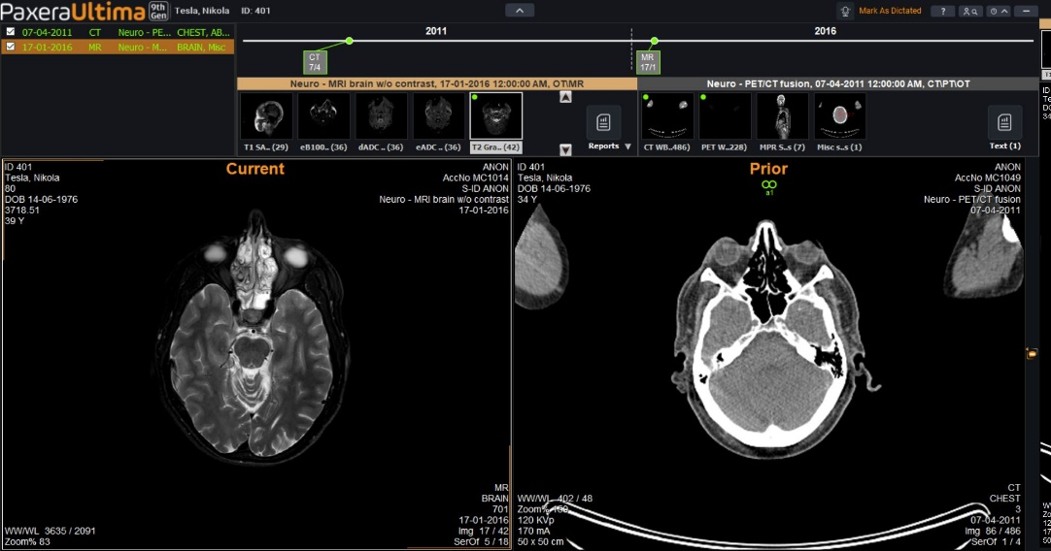

**Enables effortless comparison of current and prior studies with an integrated patient history timeline.**

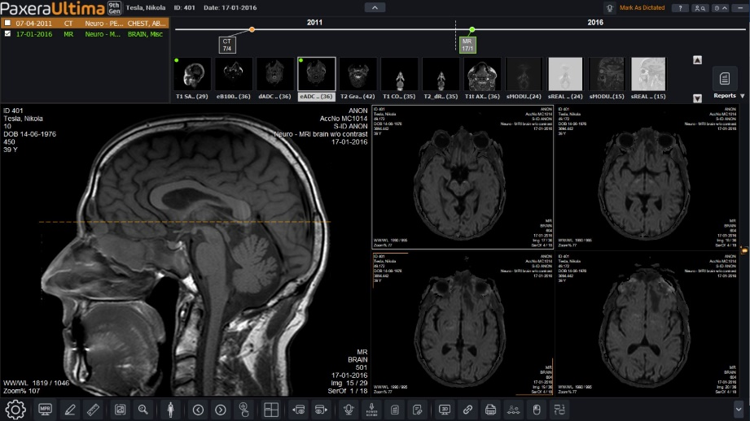

**Offers fast streaming retrieval for instant access to full diagnostic, non-compressed images.**

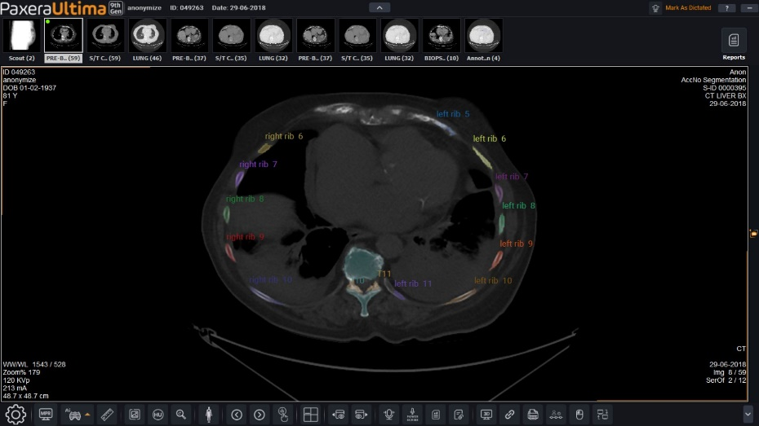

**Offers automatic spine labelling and rib counting**

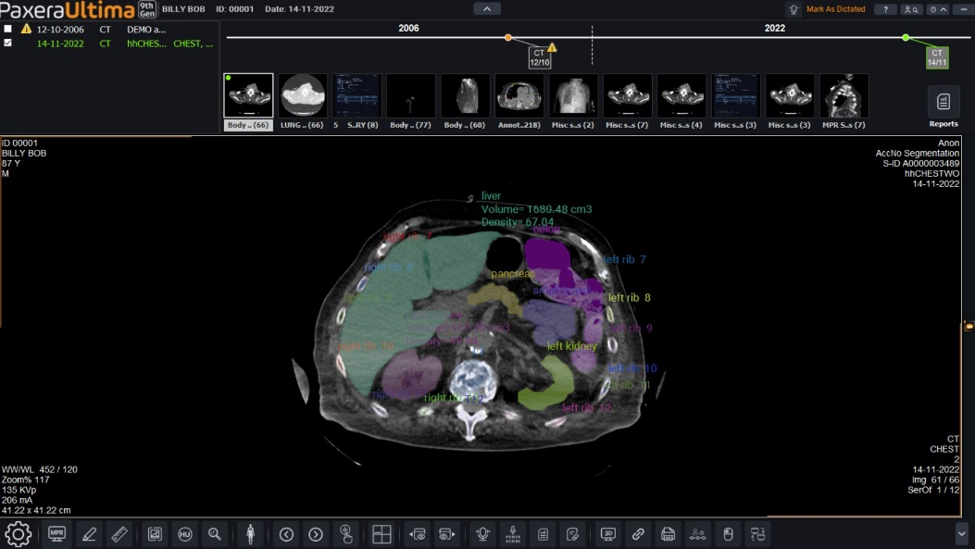

**Automatic organs segmentation with radiomics analysis**

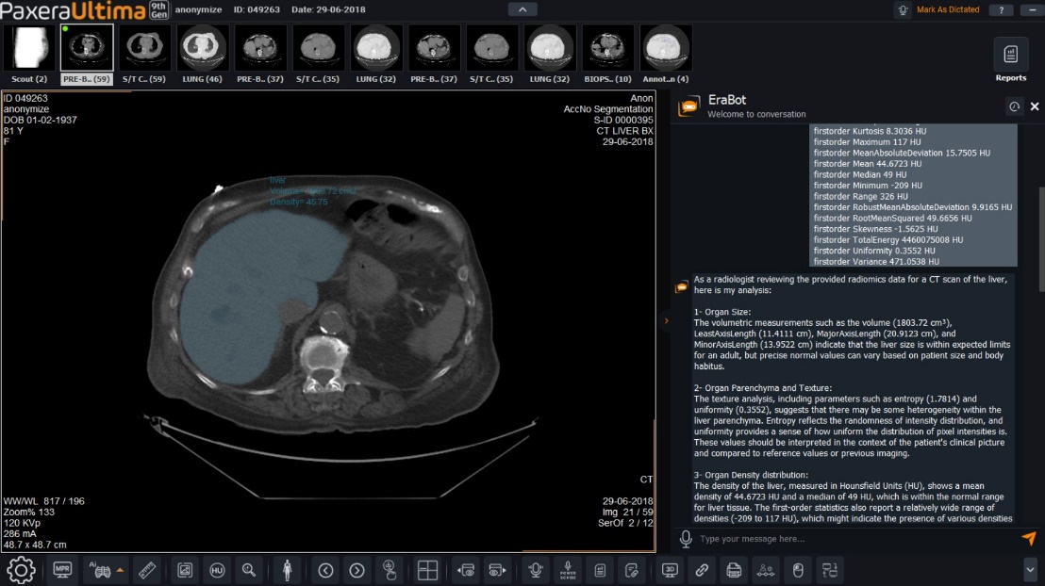

**Intelligent Chat-Bot to provide analysis of radiomics and provide preliminary reports**

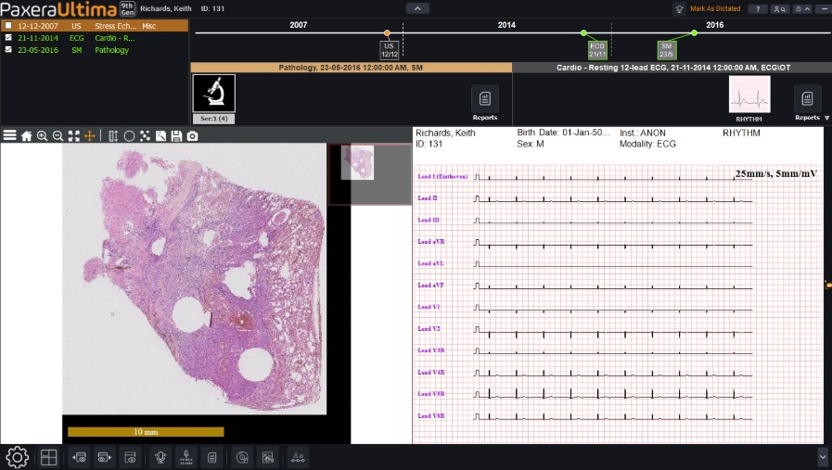

**Multi-modality, comprehensive diagnostic viewer for a full range of imaging examinations.**



**Features an easy-to-use printing tool compatible with both DICOM and non-DICOM printers**



**Incorporates precise dose measurement tools for enhanced patient safety and care.**

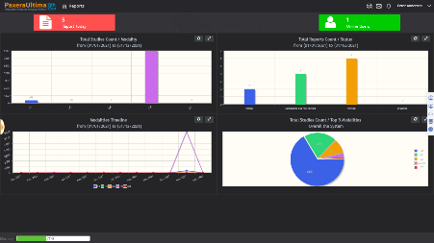

**Equipped with a real-time monitoring tool that harnesses big data for valuable insights.**

### PaxeraUltima 9th Gen at a Glance

* Universal worklist with distributed workload allocation
* AI Assisted diagnosis
* Auto Spine labeling
* Rib counting
* Organ analysis (radiomics)
* 117 Organ segmentation
* Zero footprint access to all of your enterprise medical images
* Ultra-fast streaming technology for instant access to medical images
* AI embedded for organ segmentation, rib counting and spine labelling.
* Advanced visualization to help you quantify and qualify results more accurately
* Enhanced reporting with dictation transcription, customizable templates, and voice recognition
* Built-in Peer-Review, ED discrepancy, and Critical Results
* Physician portal to access studies from any smart device and browser
* CareRad app to securely deliver medical studies and reports to patients’ mobile devices
* Interoperable with all EMR / EHR systems
* XDS/CDSI-b – standards-based Cross-Enterprise Document and image sharing
* Cost-effective and scalable to match your business growth

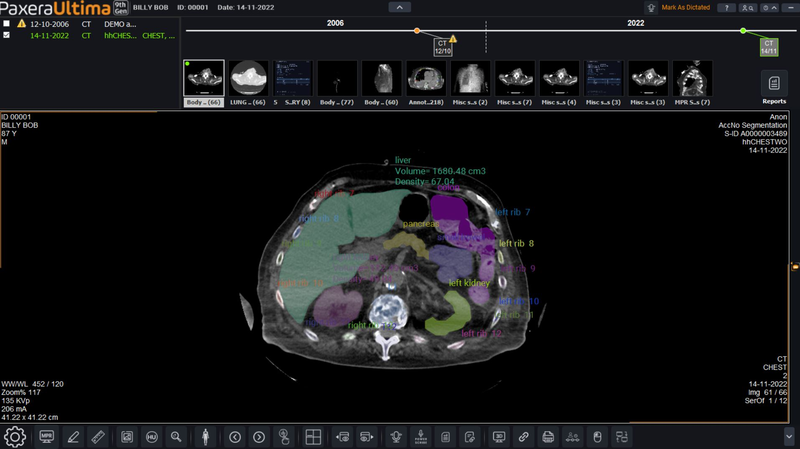

### PaxeraUltima Benefits:

* Ultra-fast streaming technology ensuring the highest productivity for all users
* Performance enhancements resulting in faster time to first image and shorter total data downloads (6X the Ultima 8)
* Interfaces with any DICOM archive
* View studies anywhere, anytime on any internet-connected device
* Interactive advanced visualization tools including MIP, MPR, and 3D
* 100% HIPPA compliant sharing module integrated with social media, MIRC, and Box
* Advanced patient portal access included in the proposal

### PaxeraUltima Instant Chat & Secure Messaging:

* Live chat allows interaction with online users, enhancing real-time communication.
* Drag-and-drop functionality in the chat box for immediate study collaboration.
* Automatically opens received study links in the Ultima360 viewer for efficient access.
* Offline inbox organizes messages by urgency and date, ensuring communication tracking.
* Chat history preserved for up to one year, supporting detailed record-keeping.
* Facilitates information sharing within the same or across different servers and locations, promoting collaborative diagnostics.
* Simplifies the consultation process through rapid, effective communication channels.
* Group chat feature significantly aids in the efficient sharing and discussion process among teams.

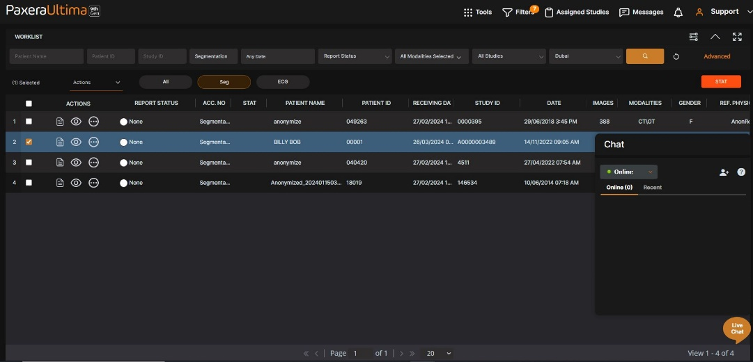

### Image Manipulation and Visualization:

* Customizable image windows allow for varied format splits tailored to user preferences.
* Enhanced zoom and pan capabilities for detailed image examination.
* Adjustable window width and level with presets for optimal image clarity.
* Color adjustments for contrast and brightness ensure superior image quality.
* Continuous playback (cine) mode for viewing series instances seamlessly.
* Facility to copy images directly to the clipboard for use in other applications.
* Streamlined scrolling for image navigation using keyboard or mouse inputs.
* Displays critical image details in real-time, including study info and zoom levels.

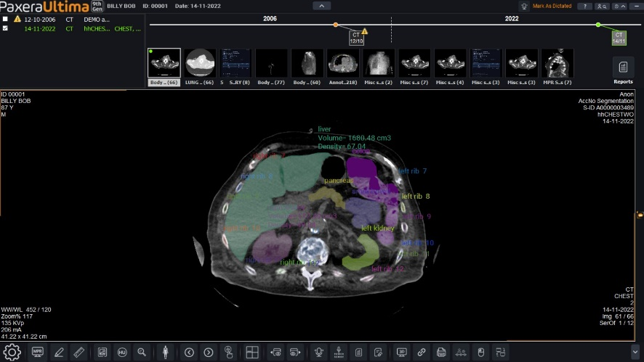

### Tools

* Equipped with versatile tools for image manipulation: invert, rotate, resize, and crop.
* Offers a range of filters like sharpen, smooth, and emboss for enhanced image clarity.
* Includes various measurement tools for distance, area, ellipsoids, angles, and Cobb angles.
* Features CT number tracking (Hounsfield units) for precise region analysis.
* 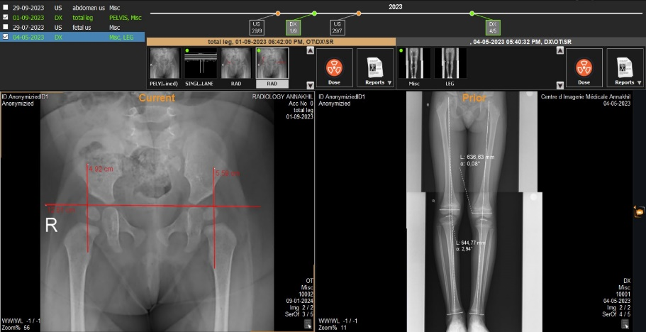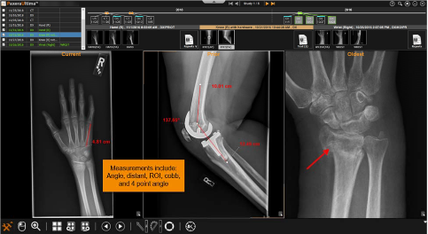Provides comprehensive annotation tools for detailed image marking and notes.

### Archiving and Study Transfer

* Enables archiving to both local storage and DELL/NTT Data infrastructure for secure data management.
* Facilitates study transfers to any DICOM-compatible device, including servers and CD publishing systems.
* Utilizes advanced encryption for data at rest and in transit, aligning with HIPAA and other healthcare regulations for maximum security.
* Offers scalable and flexible cloud archiving for easy access and robust disaster recovery.
* Features automated backups to safeguard data integrity and availability against unforeseen data loss.
* Adheres to industry interoperability standards, like IHE profiles, ensuring seamless data exchange across healthcare systems.
* Provides granular access controls for secure data management, restricting access to authorized users only.
* Optimizes bandwidth for efficient study transfers, crucial for handling large imaging data volumes.
* Supports archiving and data sharing across multiple sites, essential for large healthcare networks.
* Offers data anonymization capabilities to utilize patient data in research while ensuring privacy.

## **AI for diagnostic assistance**

### Mammography module

Mammo AI detects lesion locations, malignant and benign classifications (distortionsarchitectural, calcifications, and masses), density and BI-RAD categories.

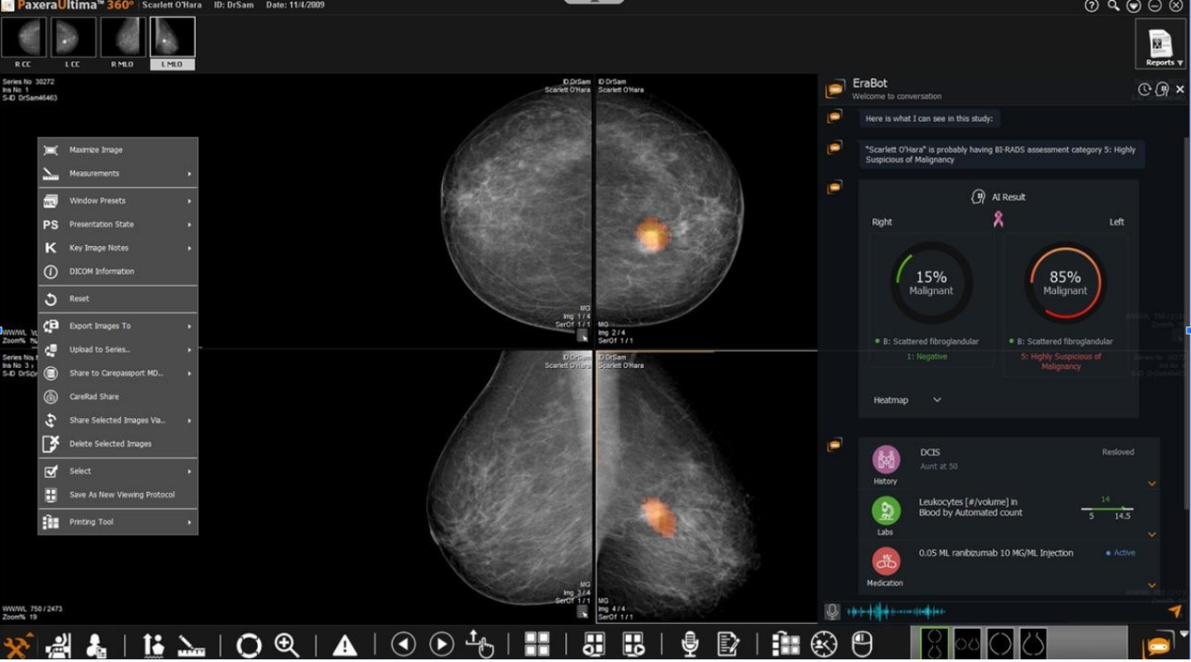Trained with 13,360 high-quality annotated images.

### CT module

CT AI detects intracranial hemorrhage and its subtypes, including: epidural, subdural, intraparenchymal, intraventricular and subarachnoid.

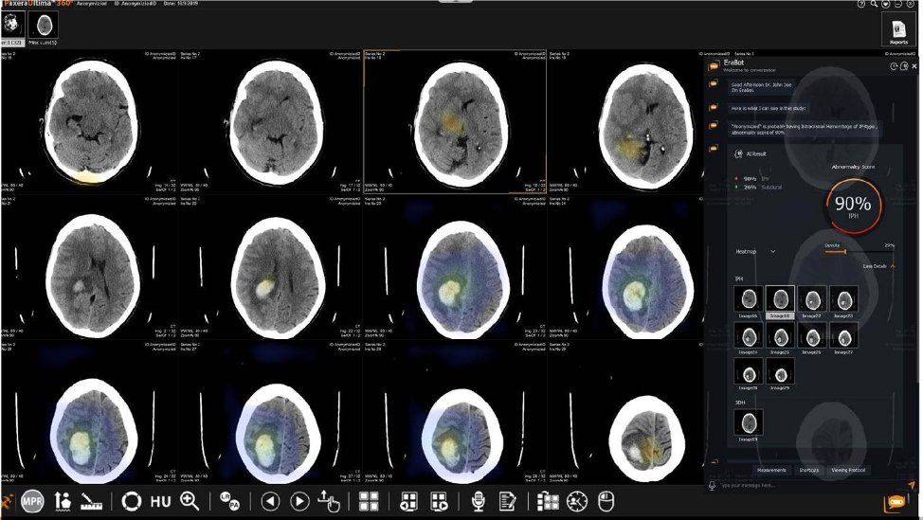Trained with 36,000 high-quality annotated images.

### Pulmonary radiography

Thoracic AI detects 10 classes, including consolidation, pleural effusion, atelectasis, nodule, mediastinal enlargement, pneumothorax, etc. Supports tuberculosis screening.

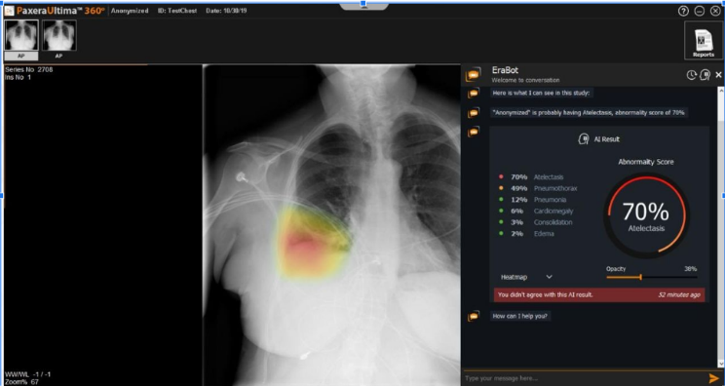Trained with 600,000 high-quality labeled and annotated images.

### AI to improve workflow:

PaxeraAI detects acute abnormalities as soon as they enter the worklist, helping radiologists prioritize life-threatening cases, improve efficiency and expedite patient care.

PaxeraAI is designed to learn and improve its performance as it interacts with radiologists and collects and stores information.

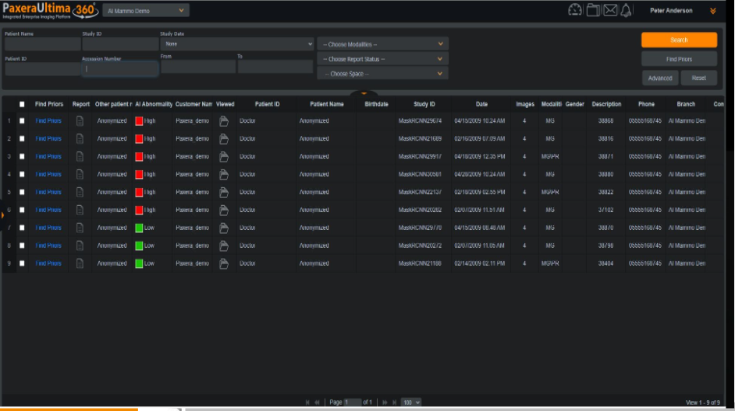The PaxeraAI module receives data via a chatbot-style questionnaire during a study reading and uses the information for analysis and to improve the AI's functions with each subsequent task. The anonymized data is also added to the PaxeraAI database and is accessible via PaxeraUltima PACS

## **PaxeraRep: Medical Reporting Module**

* Seamless integration with the PaxeraArchive (PACS) solution from PaxeraHealth.
* Web-enabled interface.
* Integrates with Nuance Power Scribe, and plug ‘n’ play for Dragon Naturally Speaking.
* The powerful multi-level patient directory that supports multi-level studies.
* Fast and flexible search tool to quickly retrieve the required studies.
* Compliant with DICOM 3.0 standards.
* Supports HL7 protocol for full integration as well as any HL7-compliant HIS.
* Enhanced security for patient data protection and HIPAA compliance.
* Easily upgradeable to meet future requirements.
* Multi-lingual interface.
* 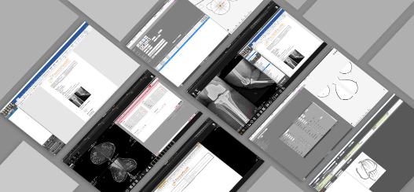 Facilitates generating multiple reports per study, enhancing documentation flexibility.
* Provides comprehensive access to a patient's historical reports, ensuring complete medical records are readily available.
* Allows for the creation of customizable report text using predefined text blocks, streamlining the reporting process.
* Offers the capability to generate formal report letters, automatically incorporating patient details, procedures, and addresses.
* Simplifies patient and study searches with filters like name, DOB, registration number, modality, etc., for quick retrieval.
* Enables viewing of a patient's historical and current reports simultaneously on a single screen for comparative analysis.
* Supports embedding study images directly into reports from a sidebar, complete with pre-insertion image adjustments (e.g., window width/level).
* Customizable keyboard shortcuts expedite the report writing process, improving efficiency.

Provides versatile report export options, including HTML, PDF, and DICOM SR formats for diverse sharing needs.

* Allows for the integration of scanned documents into the system, ensuring all reports are digitized and accessible.
* Enables direct report dissemination via email or fax, facilitating efficient communication with healthcare professionals.
* Features a report dictation tool, simplifying the creation of reports through voice recognition.
* Supports the import and export of patient reports from external sources, enhancing data interoperability.
* Equipped with advanced analytics capabilities to derive actionable insights from stored medical imaging data, such as identifying trends in diagnoses and treatment patterns.

### Reporting Tools:

Elevate your medical reporting with our versatile suite of reporting platforms, designed to cater to every need and specialty. Our suite encompasses web reports, advanced reports, and structured reports, each meticulously developed for Cath., echo, EPS, MG, and more studies. Embrace efficiency, sophistication, and unparalleled flexibility in your reporting process.

#### Web Report: Simplify with Elegance

* Jumpstart your reporting with our Web Report, the quintessential tool for healthcare professionals seeking simplicity without compromise. Effortlessly view and write reports, leveraging simplified features for maximum efficiency.
* Enjoy the convenience of loading existing templates from a curated section, ensuring you're always on point and relevant.
* Personalize your reports with the option to insert a custom header, incorporating your logo and a structured table, setting a professional tone from the outset.

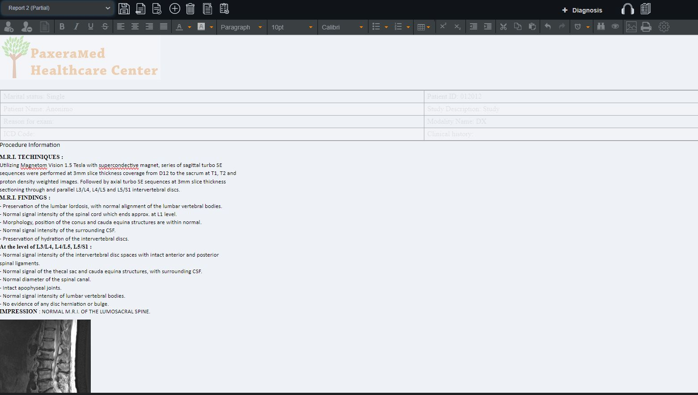

#### Advanced Report: Unleash Your Creativity

* Our Advanced Report tool integrates seamlessly with Microsoft Word, offering you the full spectrum of text editing features. Unleash your creativity and precision, crafting reports that not only inform but also impress.
* Tailor every aspect of your report to reflect the highest standards of professionalism and care, making every word count.

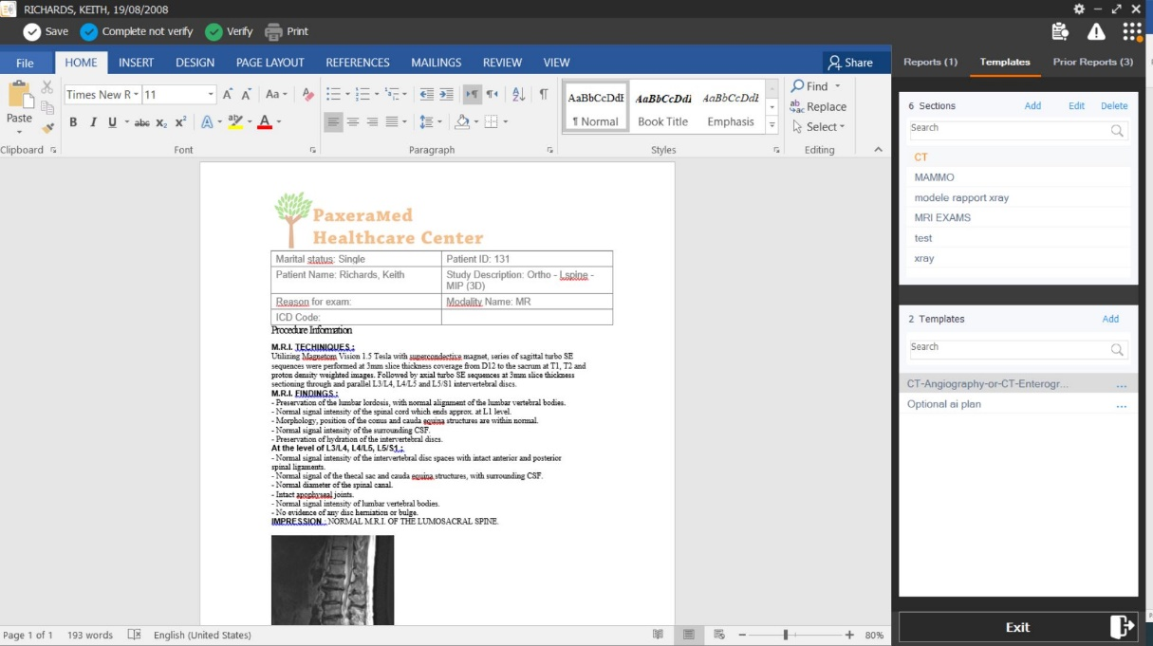

## **Cardio Structural Reports**

* Revolutionize your reporting workflow with our Structured Report tool, designed to automate and streamline the reporting process. Engage with an intuitive wizard that guides you in selecting essential information, effortlessly creating comprehensive reports.

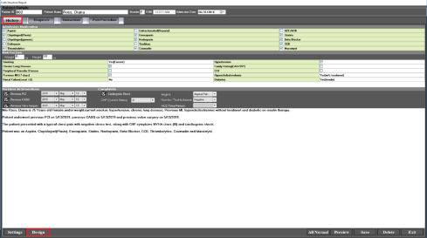**Cardio Structural Reports:**  Elevate your cardiovascular diagnostics with our specialized cardio structural reports. Designed specifically for Cath., Echo, and EPS studies, these reports provide a robust framework for detailed analysis and documentation.

## **Mammography Structural Reports**

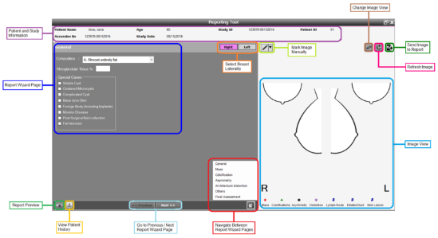**Mammography Structural Reports:** Advance your mammography diagnostics with our detailed structural reports. These reports are meticulously crafted to cover all critical aspects of mammography findings, including mass, calcifications, asymmetry, and distortion.

## **Zero-Footprint Module (PaxeraZFP):**

Just as PACS revolutionized the radiology workflow by shifting from film to digital, PaxeraHealth's Zero-Footprint technology is setting a new standard for accessing medical images and reports. Say goodbye to the clutter of films, CDs, and DVDs. Our cutting-edge, zero-footprint solution empowers healthcare facilities to access patient data directly from any browser, on any device—Windows, Apple, Android, and more—ushering in an era of unprecedented flexibility and efficiency.

**Why Choose PaxeraHealth Zero-Footprint?**

* **Streamlined Operations**: Dramatically reduce staff time spent on managing physical media, allowing your team to focus on what matters most—patient care.
* **Ease of Use**: Our intuitive interface requires no dedicated training, making it accessible to all staff members from day one.
* **Universal Access**: Radiologists and healthcare professionals can now access patient images and reports anytime, anywhere, from any web browser or mobile device, ensuring critical information is always at their fingertips.
* **Hassle-Free**: With zero-download clients, there's no need for software installation, making it a breeze to integrate into your existing workflow.
* **Seamless Integration**: Whether as a standalone solution or integrated with your current PACS system via an edge server, our zero-footprint technology fits perfectly into your healthcare ecosystem.
* **Secure and Immediate**: Enjoy instant, secure access to exam reports and images, supporting the highest standards of care without compromise.

Embrace the future of medical imaging with PaxeraHealth Zero-Footprint. Experience the freedom and flexibility of accessing patient data effortlessly, ensuring quality care remains the cornerstone of your practice. Join us in this next step of healthcare innovation—where every image, every report, is just a click away.



**Spine labeling**



**Voice recognition integration**

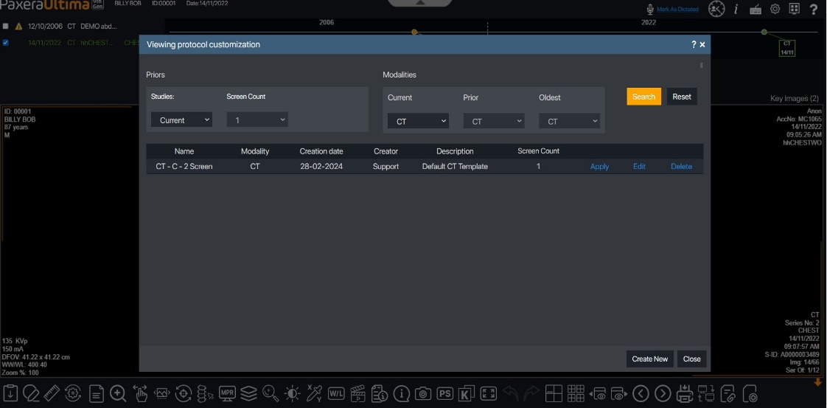

**Customize your hanging protocols on ZFP viewer**

## **PaxeraRIS**

Introducing the all-new web-based PaxeraRIS, an intuitive workflow management platform to fully control radiology data management across the enterprise. Built using cutting-edge technology to set a new level of uniqueness for the health informatics industry. It’s a fully web-based and powerful workflow management engine served by a business intelligence solution for managing big data to get the best out of your hidden treasures.

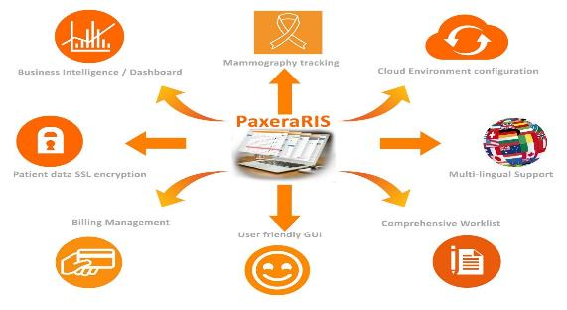PaxeraRIS Enables complete control of all radiology data and simplifies the workflow across the entire radiology department.

### PaxeraRIS at a Glance

* Fully web-based application.
* Cross-browser compatibility (Firefox, Chrome, Internet Explorer…etc.)
* Cross-platform compatibility (MAC, Windows, Linux … etc.)
* Advanced worklist search engine.
* Automatic update feature.
* Configured in a Cloud environment supporting multiple customers and branches.
* Zero-footprint (ZFP) that doesn’t require any installation or pre-configuration on the Client’s device.
* Settings are configured per-user preferences, not per-machine configuration.
* Support Single sign-on (SSO) by adding Windows authentication and Active Directory integration.
* Advanced Insurance Workflow Management System.
* Customizable Monitoring Dashboard with the following KPIs.
* Extended user rights configuration.
* Mammography tracking module.
* Monitoring of report turnaround time.
* Inclusive Turnaround Time (TAT) tracking module
* Clinical data SSL encryption.
* Supports HL7.
* Multilingual software to suit user preference.
* Visual report designer that is fully integrated with PaxeraReport; a fully-featured reporting module.
* Multi-lingual support
* Compliant with DICOM 3.0 standards
* Supports HL7 protocol for full integration with HL7-compliant HMIS’

### PaxeraRIS Benefits:

* 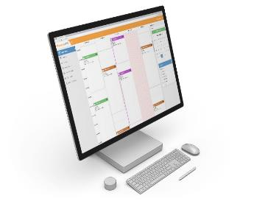A fully automated workflow with massively reduced paperwork.

Improves your productivity and business performance.

Faster and full data management.

Use it anywhere on cloud service.

Opens from any browser or even platform.

Flexible Design your monitoring dashboard report.

Enhanced patient data security.

* Fully and seamlessly integrated with existing platforms.
* Tightly integrated PaxeraUltima PACS solution.
* Empowered RIS administrative tools for better control.
* Scalable to fit your business needs.
* Real-time monitoring and data analytics for optimized decision-making.
* Multilingual software to suit international organizations.
* Enhanced security of patient data protection using SSL encryption
* The only practice automation technology with a patient-focused workflow management approach.
* Advanced insurance workflow management.
* Very user-friendly GUI that does not need any specialized training.

### Full automation for maximizing resources utilization

PaxeraRIS is built to provide a fully automated workflow with massively reduced paperwork that saves time for your staff helps utilize them in more tasks and even grows your business without the need to increase staff members, also reduces human error probabilities.

### Comprehensive Scheduling & Registration

With the new scheduling modules, the radiology workflow is streamlined while simultaneously reducing typing errors and ensuring consistent patient data allowing easy administration and planning of all types of appointments and procedures.

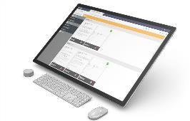A more user-friendly registration process with electronic data capture. All relevant observations including the examination or special care for the patient can be recorded as text notes by the front desk staff if required.

PaxeraRIS Supports FHIR, enables FHIR clients to retrieve data from a server without performing more expensive periodic polling queries, and enables workflow event-based notifications that keep applications data in sync.

**Appointment management:**

Managing external department order request.

**PaxeraRIS for Radiologists:**

* Boosting productivity through a faster reporting service and time-saving practice.
* Better collaboration with colleagues and referring physicians helps better diagnosis and reporting service.
* Capture all patient clinical history that helps in the precision of diagnosis.

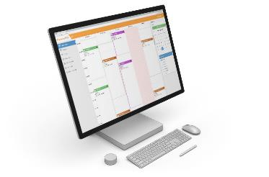Comprehensive Worklist

* Fast and flexible search tool for instant retrieval of the required studies empowered with a user-friendly GUI which enables the user to easily edit, cancel, delete, print job orders, view job order logs, and reschedule canceled job orders.

**Billing Management**

* Handles multiple payment methods from cash, insurance, and insurance cash. Also, a huge number of accounting reports are supported.
* Advanced report designer that is a fully-featured reporting module.
* User-friendly GUI where users can easily create reports according to almost all system variables.

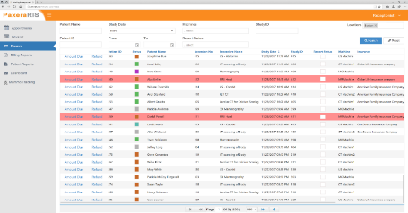

### Dashboard for Business Intelligence

**PaxeraRIS** Dashboard is a business intelligence solution that will revolutionize the way you view the information you need, Simple, interactive & customizable to empower you with superb real-time monitoring of workflow and business performance, it improves the decision-making process and helps set plans for the future.

**PaxeraRIS** dashboard collects and analyzes data in real-time from the whole organization.

Generated reports and dashboard views are easily customizable to monitor critical metrics and ensure steady progress toward success.

**PaxeraRIS** Dashboard reports don’t only include billing and operational activities, but also include reading workflow and other indices like:

* Several orders, exams, and reports.
* Reports verified per radiologists.
* Arrived time for exam time.
* Exam time to report time.
* Arrived on time to report time.
* Performed/unperformed exams.
* Order per status
* Exams per machine.
* Revenue per branch/machine.
* Total profit, refund, remaining and canceled orders.
* Report turnaround time.
* Exams per branch and per year

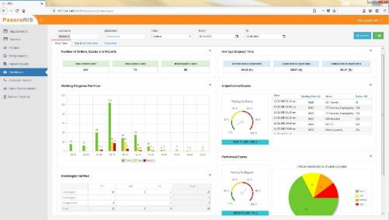

**Problem Overview:** In the dynamic environment of radiology, attending radiologists may find variances with preliminary readings provided by radiology residents, including those from emergency departments (EDs), residents on night-call, and Tele-radiology groups. Traditionally, these discrepancies, especially in academic settings with residents covering night shifts, are managed through a Complex process. Preliminary emergent study readings conducted overnight await final assessments by subspecialty attendings the following day. Yet, the tracking and formal reporting of these discrepancies often fall through the cracks, exacerbated by manual communication processes and system incompatibilities across departments. This gap can lead to overlooked discrepancies and lost reports, compromising patient care quality.

**Innovative Solution: Discrepancy Tracking Tool** To address this critical gap, we introduce an advanced Discrepancies Tracking Tool designed to capture and record all preliminary reports made by ED physicians, residents, and Tele-radiology groups. This tool facilitates a streamlined review process, allowing attending radiologists or consultants to assess, amend, and formally submit these reports. The tool also ensures the notification of amended diagnostic reports back to the original reporters within their respective departments, promoting a seamless loop of communication and feedback.

**Key Advantages:**

* **Enhanced Efficiency**: Automates the tracking of discrepancies, eliminating the reliance on manual and inefficient home-grown solutions.
* **Improved Accuracy**: Ensures that all preliminary readings are reviewed and discrepancies are formally reported and addressed, enhancing diagnostic accuracy.
* **Seamless Communication**: Facilitates direct notifications to the main reporter, improving collaboration and feedback within departments.
* **Integrated Workflow**: Embedded within the study worklist, a dedicated column for Discrepancies ensures easy access and visibility, making discrepancy management an integral part of the daily workflow.

Our Discrepancies Tracking Tool not only optimizes the management of discrepancies but also reinforces the commitment to delivering high-quality patient care through improved accuracy and communication. By bridging the gap between preliminary readings and final reports, we empower radiology departments to uphold the highest standards of diagnostic excellence.

## **PaxeraBroker HL7 & Worklist Generator**

PaxeraHealth HL7-DICOM server, PaxeraBroker, is the ideal solution to connect the imaging department (radiology, cardiology, etc.) to any Hospital Information System (HIS) using HL7 messaging protocol by seamlessly transferring reservations and orders from hospital reception to the imaging department. In addition, it allows the billing and inventory reports produced by the imaging department to be transferred to the HIS so that they can be archived inside the Electronic Health Record (EHR).

**PaxeraBroker** also manages the basic DICOM modality worklist and MPPS transactions to conclude the integration part of the complete HIS/RIS/PACS environment. By updating patient data, this solution supports the DICOM management classes to assure maximum integration capability between “HIS” (the information systems) and “PACS” (the imaging systems).

**PaxeraBroker** handles a typical message flow, Acknowledgment mechanism, queue management, multiple queue support, priority queuing, and direct query of data sources.

### PaxeraBroker Key Features

* Supports all DICOM management classes.
* Supports HL7 to DICOM conversion and vice versa.
* Handles the integration between PACS and HIS environments.

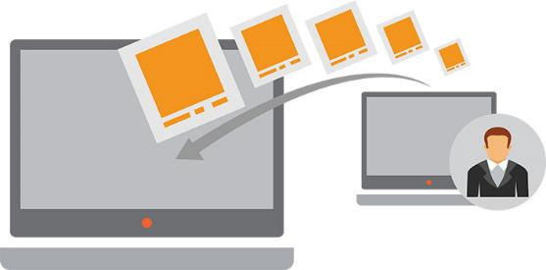

## **Critical Results**

The Critical Results Module is a pivotal component of our system, designed to meticulously manage and convey medical test results of critical significance to a patient's health. This module stands as a safeguard against the potential for critical information to be overlooked due to communication lapses, thereby bolstering patient safety and ensuring meticulous documentation of result dissemination.

Upon identification of new or unforeseen findings within an imaging study—findings that may pose a risk of mortality or significant morbidity—the module promptly notifies the patient's healthcare provider or referring physician. This protocol aligns with the stringent standards and guidelines recommended by the Joint Commission and the American College of Radiology, reflecting our commitment to upholding the highest standards of care.

Key features of the Critical Results Module include:

* **Integrated Alert System**: Incorporates an advanced alert mechanism that requires acknowledgment, ensuring that every critical finding is addressed and acted upon without delay.
* **Comprehensive Tracking**: Maintains diligent tracking of all alerts from generation to acknowledgment, offering complete visibility and accountability.
* **Versatile Communication Channels**: Utilizes multiple methods of communication, such as SMS and email, to ensure timely and efficient delivery of critical result notifications.

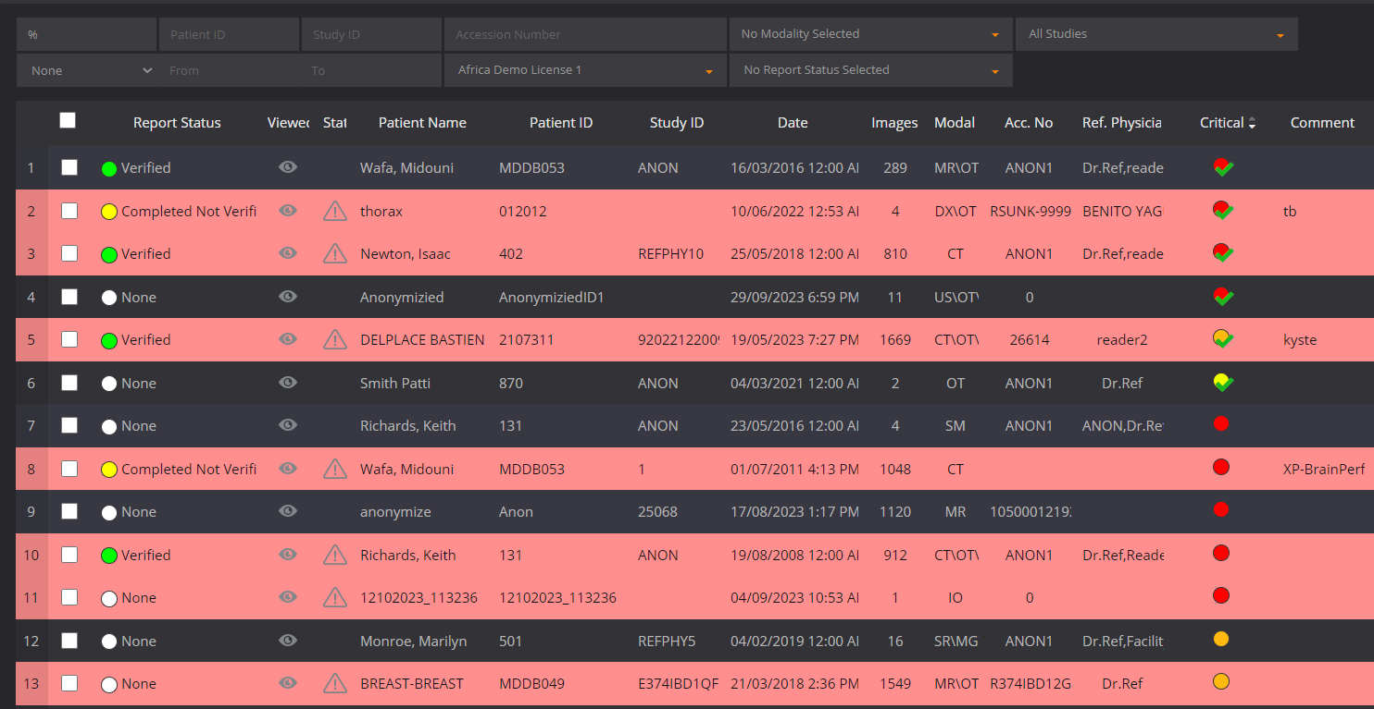Designed for scenarios where prompt action is paramount, this feature guarantees that the referring physician is immediately informed about critical cases, facilitating swift and appropriate intervention. Moreover, within the study worklist, a dedicated column for critical results ensures easy identification and access to these urgent findings, streamlining the workflow and enhancing the responsiveness to patient needs.

## **Peer Review Module**

The Peer Review (PR) module is a cornerstone of our commitment to fostering continuous improvement and excellence in medical practice. Designed to facilitate the review of fellow physicians' work in a secure, constructive environment, this module enhances the quality assurance process across all study workflows.

At its core, the Peer Review process aims to provide meaningful feedback through grading and scoring, conducted in a confidential and non-confrontational manner. This approach ensures that feedback is received as intended—constructive, aimed at improvement, and respectful. It's an invaluable tool for radiologists, providing insights into their medical and clinical knowledge performance, thereby directly contributing to the enhancement of patient care quality.

Key features of the Peer Review module include:

* **Random Case Selection**: Cases for review are randomly selected to cover a broad range of imaging modalities and provide a balanced assessment of current performance.
* **Timely Evaluation**: Focuses on reviewing studies from recent time intervals, ensuring feedback is relevant and reflective of current practices.
* **Constructive Feedback**: Emphasizes non-punitive, constructive feedback, fostering an environment of growth and learning.
* **Dedicated Workflow Integration**: Seamlessly integrated into the study worklist with a specific column for peer review, making it easily accessible and part of the routine workflow.

This module not only supports the professional development of radiologists but also acts as a proactive measure in maintaining high standards of patient care. By encouraging open dialogue and feedback among peers, the Peer Review module is an essential element in the pursuit of clinical excellence and quality assurance within healthcare practices.

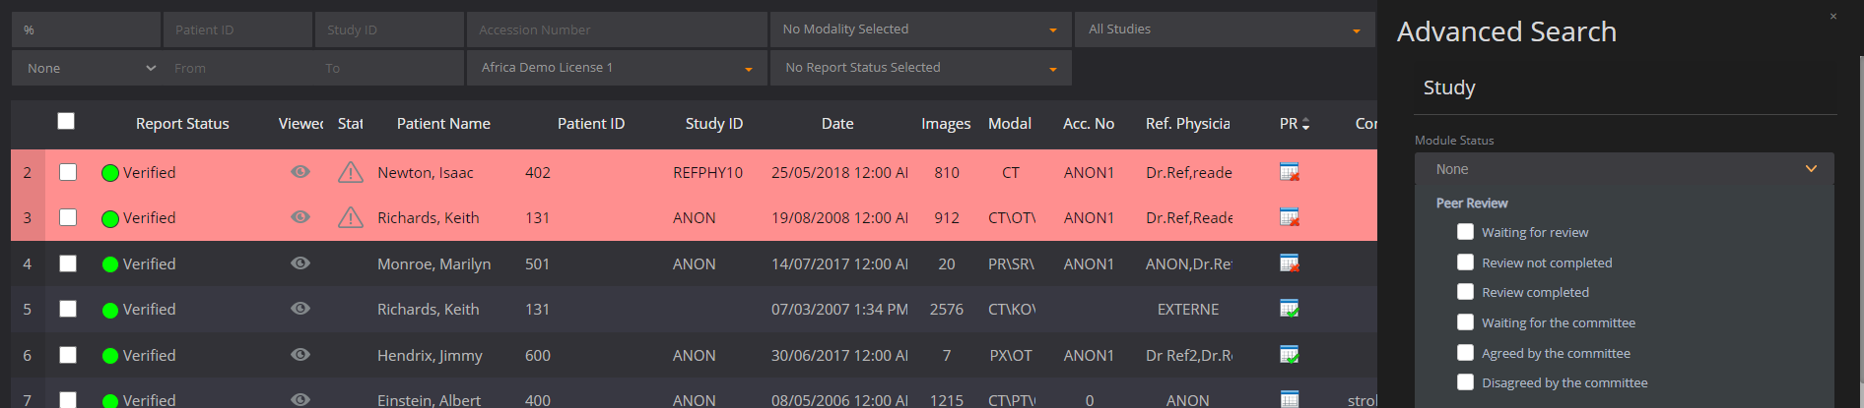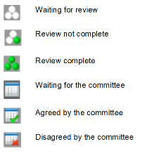

## **Emergency Department Discrepancies Module**

**Problem Overview:** In the dynamic environment of radiology, attending radiologists may find variances with preliminary readings provided by radiology residents, including those from emergency departments (EDs), residents on night-call, and Tele-radiology groups. Traditionally, these discrepancies, especially in academic settings with residents covering night shifts, are managed through a Complex process. Preliminary emergent study readings conducted overnight await final assessments by subspecialty attendings the following day. Yet, the tracking and formal reporting of these discrepancies often fall through the cracks, exacerbated by manual communication processes and system incompatibilities across departments. This gap can lead to overlooked discrepancies and lost reports, compromising patient care quality.

**Innovative Solution: Discrepancy Tracking Tool** To address this critical gap, we introduce an advanced Discrepancies Tracking Tool designed to capture and record all preliminary reports made by ED physicians, residents, and Tele-radiology groups. This tool facilitates a streamlined review process, allowing attending radiologists or consultants to assess, amend, and formally submit these reports. The tool also ensures the notification of amended diagnostic reports back to the original reporters within their respective departments, promoting a seamless loop of communication and feedback.

**Key Advantages:**

* **Enhanced Efficiency**: Automates the tracking of discrepancies, eliminating the reliance on manual and inefficient home-grown solutions.
* **Improved Accuracy**: Ensures that all preliminary readings are reviewed and discrepancies are formally reported and addressed, enhancing diagnostic accuracy.
* **Seamless Communication**: Facilitates direct notifications to the main reporter, improving collaboration and feedback within departments.
* **Integrated Workflow**: Embedded within the study worklist, a dedicated column for Discrepancies ensures easy access and visibility, making discrepancy management an integral part of the daily workflow.

Our Discrepancies Tracking Tool not only optimizes the management of discrepancies but also reinforces the commitment to delivering high-quality patient care through improved accuracy and communication. By bridging the gap between preliminary readings and final reports, we empower radiology departments to uphold the highest standards of diagnostic excellence.

## **Sharing & Collaboration:**

The Messaging Center enables specialists to group chat, share studies, consult with co-workers, and engage in real-time collaboration without leaving the unified PACS interface.

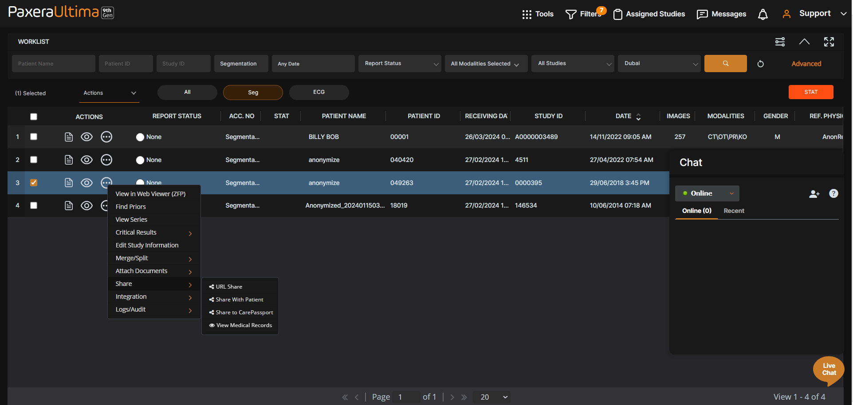

Share studies via XDS and HIE; a one-click sharing feature empowers users to send studies to other physicians for second opinions, and share images securely by anonymously posting to users’ social media accounts. These all-encompassing tools enhance the workflow and help facilities provide effective, efficient care.

## **Streamline Workflow:**

Designed with productivity in mind, the system offers the ability to browse and query from dispersed PACS, smart hanging protocols, advanced visualization, a patient history timeline, and a zero footprint (ZFP) viewer for any browser or mobile device.

The patient-centric solution benefits users by providing a single place for them to collect, store, share, and manage health data.

## **Advanced Dashboard and Business Analytics Dashboard:**

PaxeraUltima provides a real‐time analytics tool to assist in analyzing trends and identifying an area of improvement. With an intuitive statistical dashboard, PaxeraUltima ‘S dashboard provides real-time analytics tools for decision-makers to monitor critical metrics using numerous variables such as study counts, number of produced reports, and top demanded modality procedures during selected periods, allowing department heads to track and manage performance and ensure full operational capacity.

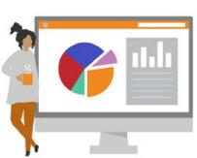The enhanced dashboard is architected with several discrete functions that allow administrators to monitor the status of the system. The dashboard also provides complete analytical data throughout the enterprise. We purposefully designed each of these functions to support rich, exploratory pathways through the data.

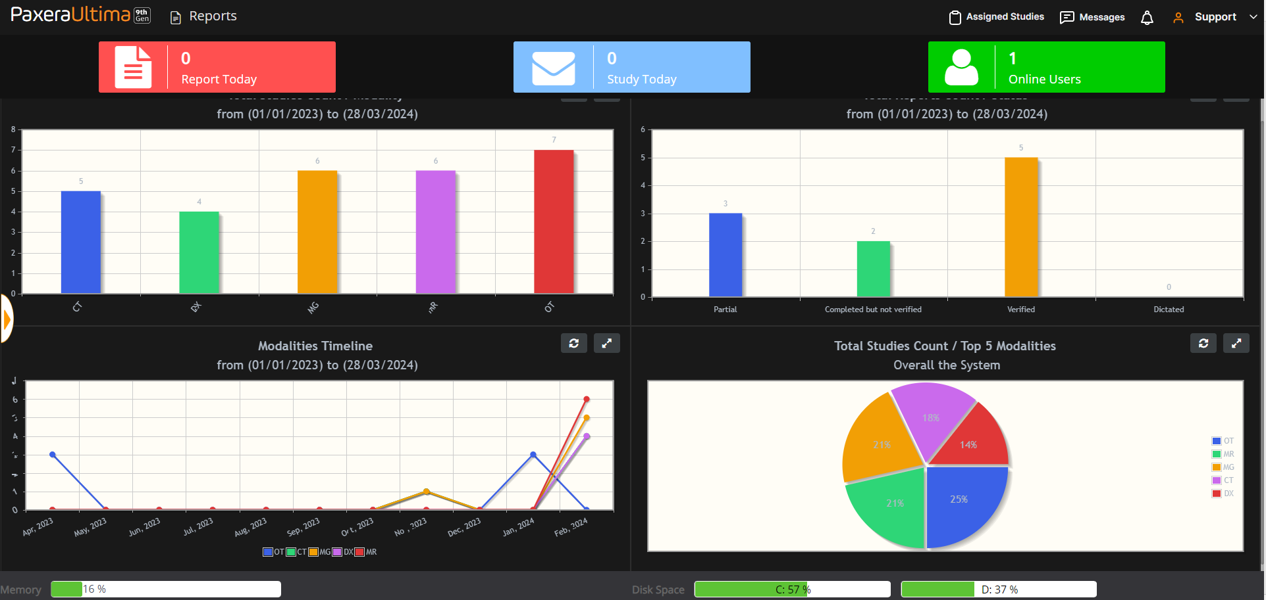

Track studies, reports, and users on the system:

* Sort studies per modality and different statuses of reports
* Select specific search criteria by date, modality, etc.
* Analytics information can be exported  
   into a report format and used for billing purposes
* Analyze trends and identify areas for improvement

The dashboard collects and analyzes data in real-time, transforming raw data into customizable metrics and KPIs from the whole organization, the reports and dashboard views are easily customizable to monitor critical metrics and ensure steady progress toward success.

## **Patient Portal Module**

Deliver value-based care with our patient-centric model. Our patient portal yields better health outcomes. Keep patients engaged with an effective messaging tool and patient-side access to medical records. Save time and resources by enabling your patients to upload their radiology images and medical data.

* Give patients secure access to their medical images and reports from any web browser or mobile device
* No downloads or software installation required
* User-friendly interface design with no dedicated training necessary
* Run as a stand-alone solution or integrate with existing PACS
* Reduce staff time and eliminate the cost of producing CD/DVD/films
* Upload studies for a second opinion
* Patients can access their information from any web browser or mobile device
* Zero‐download clients that require no software to be installed on a patient's computer
* Integrates directly with the PACS database via the edge server
* Improve patients’ satisfaction and enables users to consolidate information that has been dispersed across multiple sources.
* Stores exam reports and images with immediate, secure access to these data to support quality care
* Share medical images securely by anonymously posting studies on Facebook
* Patients can easily upload their studies and send them to other doctors for a second opinion

|  |  |
| --- | --- |
|  | ZFP - compare studies |

## **Referring Physician Portal**

In the same way, PACS has transformed the film-based workflow for the radiology departments and clinicians, Paxera referring physician portal is transforming how facilities share medical images with their referring physician by taking traditional media such as films, CDs, and DVDs away from the administration desk and replacing it with an advanced zero-footprint referring physician portal.

PaxeraHealth’s intuitive zero-footprint referring physician portal enables the referring physician to view their patient’s medical images and reports from any browser or mobile device and allows images to be downloaded or shared to anonymized.

**Referring Physician** Portal Key Features:

* ****User-friendly interface and zero-footprint viewer
* Access studies from any browser or mobile device
* Integrates directly with the PACS database
* Upload studies for a second opinion
* Reduces staff time and eliminates the cost of producing CDs, DVDs, and films User
* User-friendly interface design with no dedicated training required
* the referring physician can access their patient's information from any web browser or mobile device
* Zero-download clients that require no software to be installed on a referring physician's computer
* Integrates directly with the PACS database via the edge server
* Improve referring physicians’ satisfaction and enables users to consolidate information that has been dispersed across multiple sources.
* Stores exam reports and images with immediate, secure access to these data to support quality care

## **Tele-Radiology**

Our solution is designed to have a unique Tele-radiology capability that can eliminate any common obstacles in terms of performance, security, or high availability, here are the factors that affect the Tele-radiology in detail and how PaxeraHealth Tele-radiology solution eliminates them:

* Data size & transmission/connectivity constraints:
* Radiological images size in transmission especially with the new set of machines that produces thousands of images per study, PaxeraHealth eliminates this factor through a unique technology (PaxeraHealth Ultra-fast Streaming) through the PaxeraUltima application which provides the capability of streaming huge studies containing thousands of images in a few seconds regardless the bandwidth.
* Through that streaming technology, the user can view any image regardless the study is fully downloaded or not
* The user can perform a fully MPR process on the fly, without waiting till the study is fully streamed/downloaded.
* Security of Electronic Protected Health Information (ePHI)
* PaxeraHealth considers the Health Insurance Portability and Accountability Act (HIPAA) as a significant enhancement to both the privacy and security aspects of the healthcare industry
* PaxeraHealth enables covered entities to comply with both the HIPAA Privacy and HIPAA Security Rules
* Following HIPAA security rules, PaxeraHealth provides secure access to patient records regardless of the network environment through an encrypted and secure channel between the client and the server
* PaxeraUltima provides 256-bit SSL encryption which guarantees protected patient information in transit and at rest.
* High availability

PaxeraHealth provides a fully redundant solution that guarantees the required uptime and high availability through cutting-edge redundant infrastructure and the backend application setup to enable such redundancy.

PaxeraHealth provides different facilities and models for Tele-radiology operations as follows:

* Tele-Radiology for remote users:

The users who grant access privileges can log in to the Enterprise application (via any network connection and bandwidth) for diagnosis and reporting purposes, our unique streaming technology will accelerate the process and facilitate it for any remote user.

* + Routing to any remote site (PACS):

We can provide the capability of routing any type of study to any destination either manually or automatically (based on pre-configured rules), such routing will be based on pure DICOM communications between the PaxeraHealth system and any other PACS system.

# Scope of Work

## Installation of PaxeraHealth’s System

PaxeraHealth is committed to delivering a comprehensive solution tailored to meet our clients' specific needs. Under the scope of our work, we will:

* **Create Architecture**: PaxeraHealth will design and establish architecture within the required specifications to facilitate the archiving of acquired data on the proposed/recommended hardware solution.
* **License Provision**: PaxeraHealth will provide the necessary licensing features to enable the implementation of the solution according to the bill of quantities provided.

Additionally, PaxeraHealth offers the following specialized services, which may be available to clients based on their specific requirements and will incur additional charges:

* **Integration with Hospital Information System (HIS)**: For clients seeking to enhance operational efficiency by integrating PaxeraHealth’s system with their existing Hospital Information System (HIS), we offer customized integration services. This integration allows for seamless workflow and data exchange, enhancing the overall healthcare delivery process. Please note that this service is subject to additional costs and the feasibility of integration based on the specific HIS in use.
* **Data Migration Services**: PaxeraHealth provides data migration services for clients needing to transfer legacy data to the new system. This service includes migrating the required data according to migration standards and references to migration documents, in cooperation with the existing vendor. Our team ensures a smooth transition with minimal disruption to your operations. Given the complexity and resource requirements of data migration, this service is offered at an additional charge.

Note: Please refer to the **Software and Services** section of the **Financial** proposal for detailed information on the costs associated with these specialized services.

## Testing PaxeraHealth’s System

To ensure the seamless operation and integration of PaxeraHealth’s System into your healthcare infrastructure, comprehensive testing will be conducted. This testing phase is designed to validate the functionality, performance, and reliability of the system under real-world conditions. The testing process includes:

* **Production System Testing**: The primary objective of testing the Production System is to confirm the successful archiving of production studies from PACS into PaxeraUltima. The test will verify that the archived images are properly stored and can be efficiently recalled and viewed within the Ultima PACS environment. This step ensures that all archived data is accessible and maintains integrity within the system.
* **Production Viewer Testing**: The effectiveness of the Production viewer will be assessed based on its capability to display images over local area networks (LAN), if such networks are required or exist within the client's infrastructure. This test also evaluates the system's ability to seamlessly send images to other PACS, along with functionality for printing and burning studies onto physical media. These evaluations are crucial for ensuring that PaxeraHealth’s system provides robust, flexible, and reliable access to medical images, accommodating different network setups and requirements. The ability to perform over LAN or WAN underscores our system's adaptability to various IT environments, ensuring consistent performance and accessibility.
* **User Acceptance Testing (UAT) Support**: PaxeraHealth is committed to supporting our clients throughout the User Acceptance Testing (UAT) phase. We will provide comprehensive UAT plans and documentation, guiding you through the process of validating the system's functionality against your specific requirements. This support includes detailed test scenarios and expected outcomes to help stakeholders effectively assess the system's readiness for live deployment.

## Go-Live

Transitioning to live operations is a critical phase in the implementation of PaxeraHealth’s System. To guarantee a successful Go-Live, PaxeraHealth has developed a thorough process, ensuring that the system is fully operational, and all stakeholders are prepared for the transition. The Go-Live process includes the following steps:

* **Clearing Test Data**: Prior to Go-Live, PaxeraHealth will perform a comprehensive clean-up to remove all test data from the Production system. This step is crucial to ensure that the system starts fresh, eliminating any potential confusion or data integrity issues that could arise from leftover test data.
* **Go-Live Checklist Creation**: In collaboration with the customer, PaxeraHealth will develop a detailed Go-Live checklist. This checklist is designed to verify that all system components are correctly configured, all necessary integrations are functioning as expected, and the infrastructure is fully prepared for the transition to live operations. Additionally, this checklist will confirm that all users have received the appropriate training and are ready to utilize the system effectively from day one.
* **Provision of Go-Live Support**: Understanding the importance of support during this critical phase, PaxeraHealth will provide comprehensive Go-Live support. Our team of experts will be available to address any issues immediately, facilitate a smooth transition, and ensure that all aspects of the system operate seamlessly in a live environment. This support aims to minimize disruptions and ensure a positive experience for all users during the transition period.

## Training

PaxeraHealth is committed to providing comprehensive training to ensure that all users and administrators of the Enterprise Solution are proficient in its operation. Our training program is designed to equip staff with the necessary knowledge and skills for optimal system utilization. The program includes:

* **Training Materials and Sessions**: PaxeraHealth will supply extensive training documentation and conduct sessions that cater to the needs of all users. The training will encompass:
  + **Solution Training**: Participants will learn about the Solution's functionality, how to use it effectively, and basic troubleshooting to support smooth daily operations.
  + **Viewer Training**: Specific training on the Viewer will guide users through its features, usage, and troubleshooting methods.
* **Training Schedule Collaboration**: PaxeraHealth will collaborate with the client's team to develop a training schedule that ensures all necessary personnel are trained comprehensively. This approach guarantees thorough coverage without impacting the facility's operational workflow.
* **Ensuring Proficiency**: The objective is to ensure that both users and administrators become proficient in using the Paxera System for their daily workflow operations. The training is structured to empower them with the necessary expertise for efficient system use.
* **Certification of Training Completion**: Once users are assessed and deemed sufficiently trained, PaxeraHealth and the client will sign off on a user-training-completion document. This certification confirms that the staff are trained and expected to proficiently use the system.
* **Additional Training Options**: Should there be a need for further training after the initial program, PaxeraHealth offers additional training through professional services. This ensures that the staff can continue to develop their skills and adapt to any new features or changes in workflow.

# Project Milestones

Our approach to the implementation of PaxeraHealth’s System is underpinned by a set of strategic milestones, each designed to optimize the onboarding process and pave the way for a successful integration. These milestones form the backbone of our industry-leading customer satisfaction strategy, ensuring a seamless transition and fostering a solid foundation for growth. Below is the outline of these milestones:

* **Initial Engagement**: The journey begins with an initial site visit to understand the specific needs and environment. A project initiation document is then formulated, outlining the scope of work and responsibilities.
* **Onboarding Process** : This phase encompasses a comprehensive onboarding process, which includes:
  + **Software Training**: Ensuring users are well-versed in the operation of the software, including troubleshooting and best practices for efficiency.
  + **Data Migration Plan Development**: Creating a robust plan for data migration, ensuring legacy system compatibility and data integrity throughout the process.
* **Project Execution**: Throughout the project, our team maintains our SLA commitment, providing support, maintenance, and training to ensure continuous operation.
* **Go-Live Preparation**: As we approach the Go-Live date, a thorough checklist is created in collaboration with the client to ensure all systems are prepared for the transition.
* **User Acceptance Testing (UAT)**: Conducting a UAT to confirm the system meets all requirements and is ready for full-scale deployment.
* **Training**: Facilitating comprehensive training sessions for users, focusing on maximising the potential of the system for daily workflow operations.
* **Go-Live**: Carefully managed transition of the system from a test environment to live operations.

# Solution Technical Specifications



## **Proposed Solution:**

### Back End System Design:

|  |  |
| --- | --- |
| **Item** | **Description** |
| **Processor** |  |
| **Memory Capacity** |  |
| **Hard Drives** |  |
| **Operating System** |  |

### Front End System Design:

#### PACS Diagnostic Workstation:

|  |  |
| --- | --- |
| **Item** | **Description** |
| **Processor** | Intel Core i7 (6C, 12M cashe, base 3.1GHz, up to 4.5GHz) |
| **Memory Capacity** | **16 GB, 2 x 8 GB, DDR5, 4400 MT/s, V2** |
| **Hard Drives** | 512GB PCIe NVMeclass 40 M.2 SSD |
| **Internal Optical Drive** | 8* DVD+/-RW 9.5mm Optical Disk Drive |
| **Operating system** | Windows 10 Pro English |
| **Medical Grade Monitor** | 3MP color high brightness single head |
| **Monitor** | 24” LCD color monitor |

#### PACS Review Workstation:

|  |  |
| --- | --- |
| **Item** | **Description** |
| **Processor** | Intel Core i5 (6C, 12M cashe, base 3.1GHz, up to 4.5GHz) |
| **Memory Capacity** | **1x 8 GB, DDR5, 4400 MT/s, V2** |
| **Hard Drives** | 256GB PCIe NVMeclass 40 M.2 SSD |
| **Internal Optical Drive** | 8* DVD+/-RW 9.5mm Optical Disk Drive |
| **Operating system** | Windows 10 Pro English |
| **Monitor** | 24” LCD color monitor |

#### 3rd Party Supportive Software items

|  |  |  |
| --- | --- | --- |
| **Item** | **Description** | **QTY** |
| **Microsoft Windows server licenses** | Microsoft Windows Server 2022 |  |
| **Microsoft SQL license** | Microsoft SQL Server 2019 Standard - License |  |
| **Virtualization Software license** | VMware vSphere Essentials Plus Kit 3 years warranty |  |
| **Servers Antivirus license** | KasperskyEndpoint Security |  |

#### Required Network & Connectivity:

* A minimum network speed of 1GB is required between all imaging modalities and the main radiology department's PACS server room